i) Run all of the CREATE TABLE statements from Appendix A on MySQL to get your database established. You MUST NOT change any of the table structures, data types or keys. Populate your database with the data in Appendix B.

0 marks – this is preparatory work

ii) Construct the SQL for the following and show screenshots of the results for each query. If you are unsure of how to take a screenshot, please see http://www.take-ascreenshot.org/

a) List the route number and frequency of the route operated by Moor-Dale Coaches. (1 mark)

b) What is the letter (ID) of the stand which has no routes departing from it? (2 marks)

c) Give an alphabetical ordered list of the types of bus that can fit onto Stand A. Hint: A bus can fit onto a stand if it doesn’t exceed the maximum length allowed for that stand. (4 marks)

d) What types of bus are the longest? (3 marks)

e) For all stands which have regular departures, list the stand letter and the number of routes that use that stand. (2 marks)

Important note: Query f) below will change the answer to this question. If for some reason you have attempted query f) before query e) you MUST state this before showing the screenshot of the query e) results.

f) Stand C is getting too congested, so it is planned to move service 355 to use Stand D instead. Show how you could do this with SQL. Note that simply opening DBeaver and changing the data in its datasheet view is not sufficient to score marks for this question, you must use an SQL query. (4 marks)

g) A passenger has dropped something getting off a bus in Stand B and wants to contact the bus operators serving that stand in case their lost property has been handed in. What are the e-mail addresses they need to contact? You should only include the e-mail address and no other contact information in your answer and express the answer as simply as you can. (4 marks)

h) How many bus journeys per hour are operated by Coastline? Hint: Think about how to work this out and then look back at the slides on arithmetic in SQL queries. (5 marks)

i) Give the type and length of all buses which contain the word “Dart” in the type. (4 marks)

j) Route 602 to Hexham departs from Stand A. See if you can write a query to show what types of bus may be used on this route. Hint: This query is quite challenging hence it is worth more marks than the rest so consider it carefully and allow plenty of time. It is not just 6 marks or 0 marks so if you’re unfortunately unable to finish this query you are strongly advised to submit what you have done as it may well still score some marks.

(6 marks)

i） 在MySQL上运行附录A中的所有CREATETABLE语句以建立数据库。不能更改任何表结构、数据类型或键。用附录B中的数据填充数据库。

0分–这是准备工作

ii）为以下内容构造SQL，并显示每个查询结果的屏幕截图。如果您不确定如何拍摄屏幕截图，请参阅http://www.take-a screenshot.org/

a） 列出Moor Dale Coach运营的路线编号和频率。（1分）

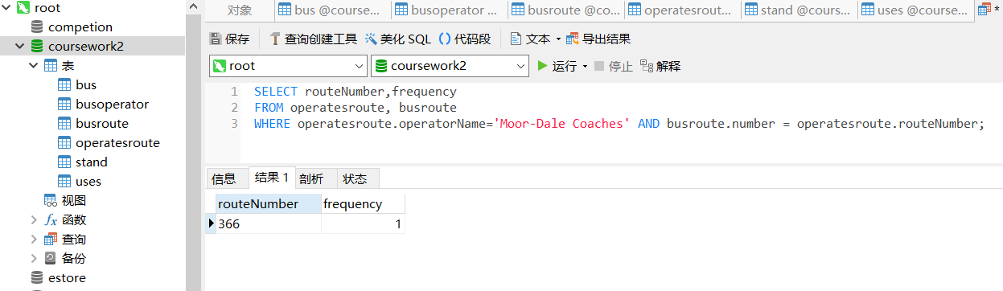

b） 没有路线离开的展台的字母（ID）是什么？（2分）

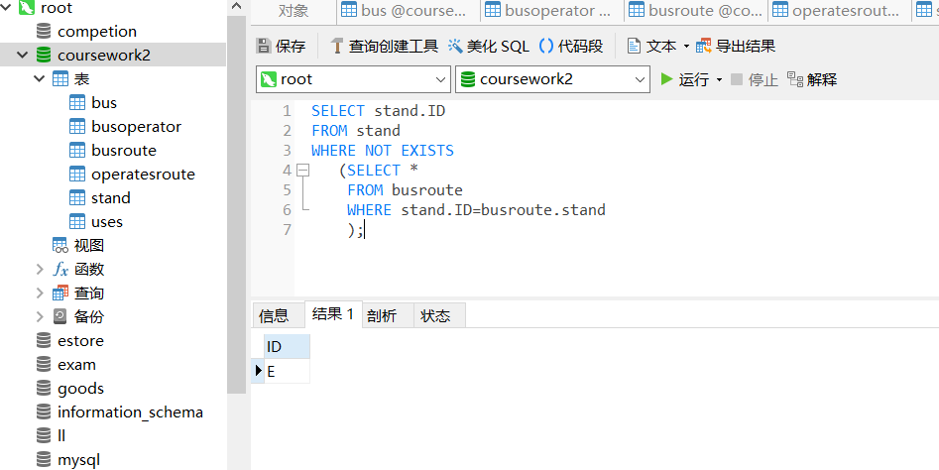

c） 按字母顺序列出可安装在支架A上的总线类型。提示：如果总线不超过支架允许的最大长度，则可以安装在支架上。（4分）

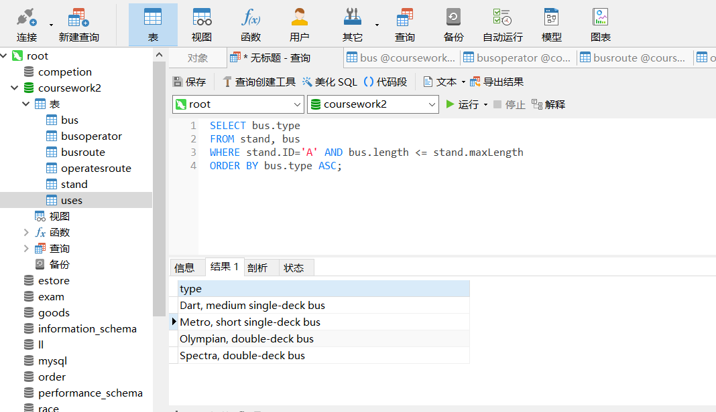

d） 什么类型的公共汽车最长？（3分）

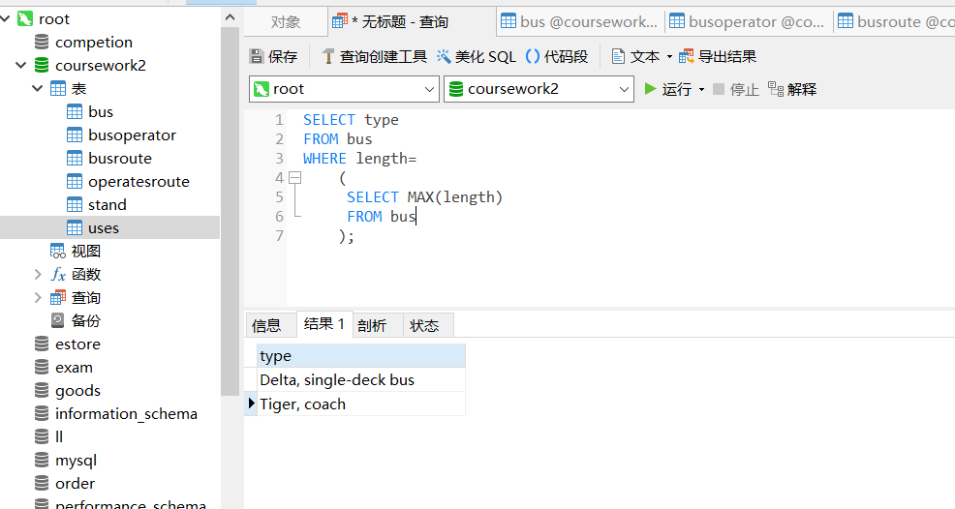

e） 对于所有定期发车的停机位，列出停机位字母和使用该停机位的路线数。（2分）

重要提示：下面的查询f）将更改此问题的答案。如果出于某种原因，您尝试在查询e）之前查询f），则必须在显示查询e）结果的屏幕截图之前说明这一点。

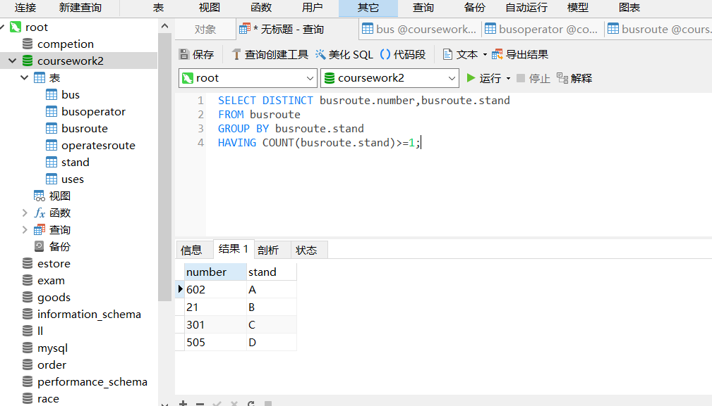

f） 展台C变得过于拥挤，因此计划将服务355改为使用展台D。展示如何使用SQL实现这一点。请注意，仅打开DBeaver并更改其数据表视图中的数据不足以对此问题打分，必须使用SQL查询。（4分）

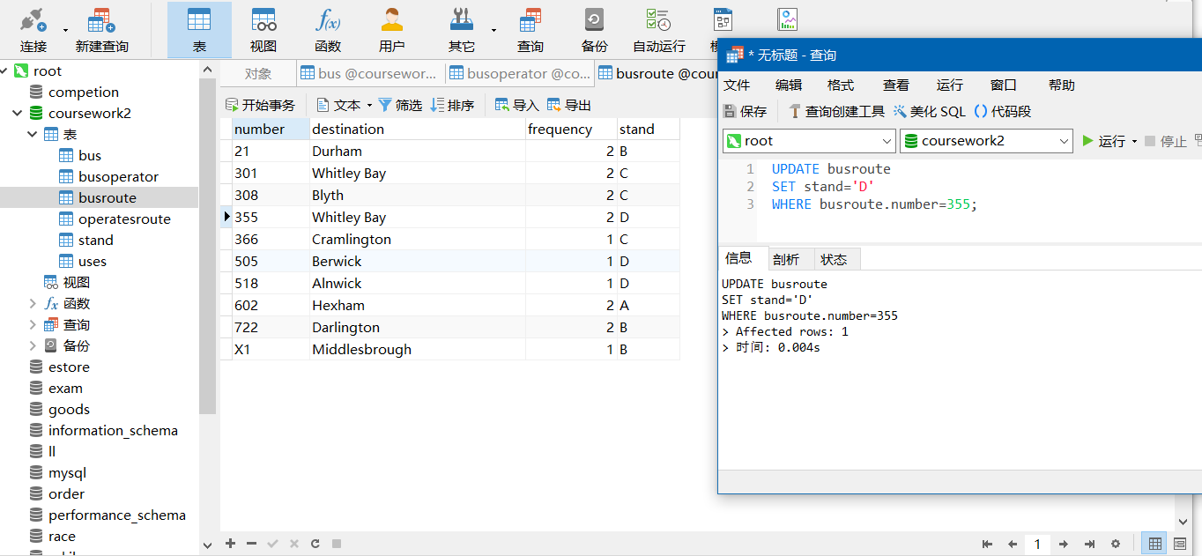

g） 一名乘客在B站台下车时丢了东西，想联系服务于该站台的公交运营商，以防他们丢失的财产被交上来。他们需要联系的电子邮件地址是什么？答案中应仅包含电子邮件地址，不包含其他联系信息，并尽可能简单地表达答案。（4分）

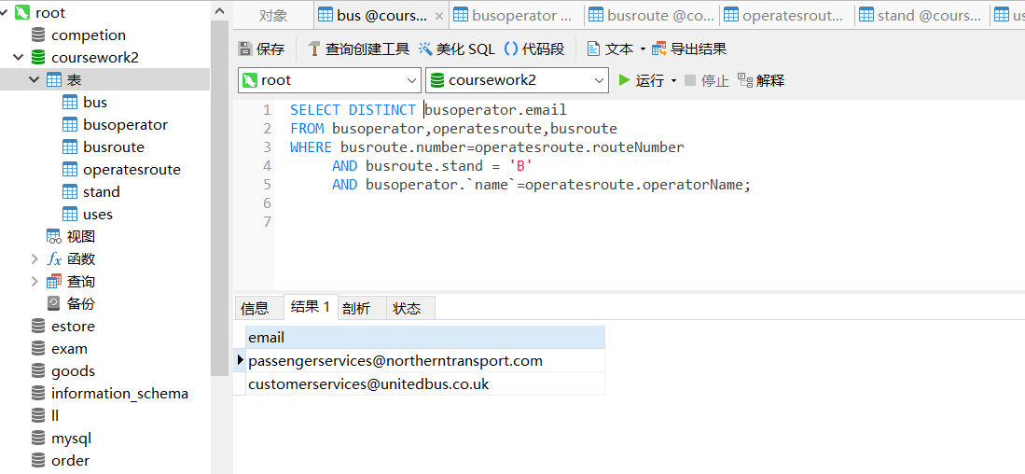

h） 海岸线每小时有多少班车？提示：考虑一下如何解决这个问题，然后回顾一下有关SQL查询中算术的幻灯片。（5分）

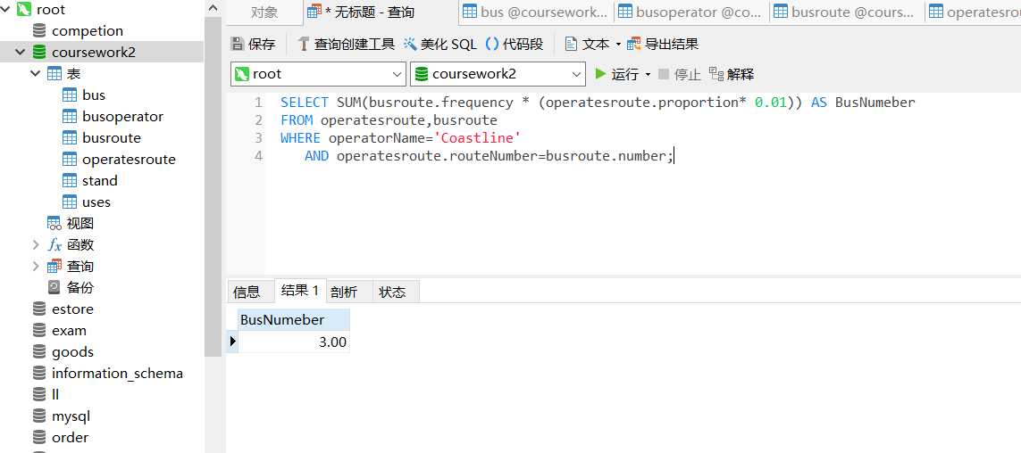

i） 给出类型中包含单词“Dart”的所有总线的类型和长度。（4分）

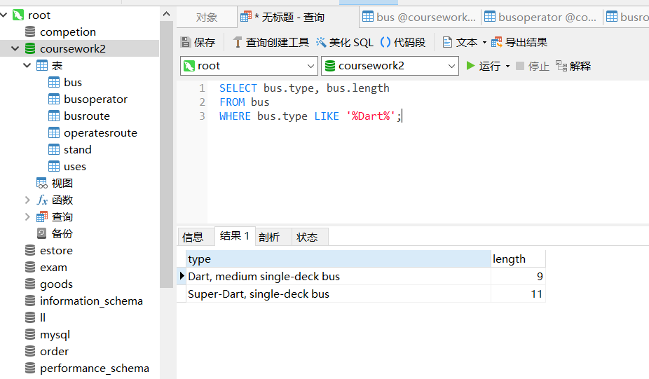

j） 到赫克瑟姆Hexham的602路从A站出发。看看你是否能写一个查询来显示这条路线上可能使用的巴士类型。提示：这个查询很有挑战性，因此它比其他的值多，所以仔细考虑并允许大量的时间。这不仅仅是6分或0分，因此，如果您不幸无法完成此查询，强烈建议您提交您所做的，因为它可能仍然会获得一些分数。（6分）

